**LCD 20X4**

**Display Character Address Code**

|  |  |  |  |  |  |  |  |  |  |  |
| --- | --- | --- | --- | --- | --- | --- | --- | --- | --- | --- |
| **Display Position** | **1** | **2** | **3** | **4** | **5** | **6** | **7** | **8** | **9** | **10** |
| DD RAM Address - Row 1 | 80 | 81 | 82 | 83 | 84 | 85 | 86 | 87 | 88 | 89 |
| DD RAM Address - Row 2 | C0 | C1 | C2 | C3 | C4 | C5 | C6 | C7 | C8 | C9 |
| DD RAM Address - Row 3 | 94 | 95 | 96 | 97 | 98 | 99 | 9A | 9B | 9C | 9D |
| DD RAM Address - Row 4 | D4 | D5 | D6 | D7 | D8 | D9 | DA | DB | DC | DD |

|  |  |  |  |  |  |  |  |  |  |  |
| --- | --- | --- | --- | --- | --- | --- | --- | --- | --- | --- |
| **Display Position** | **11** | **12** | **13** | **14** | **15** | **16** | **17** | **18** | **19** | **20** |
| DD RAM Address - Row 1 | 8A | 8B | 8C | 8D | 8E | 8F | 90 | 91 | 92 | 93 |
| DD RAM Address - Row 2 | CA | CB | CC | CD | CE | CF | D0 | D1 | D2 | D3 |
| DD RAM Address - Row 3 | 9E | 9F | A0 | A1 | A2 | A3 | A4 | A5 | A6 | A7 |
| DD RAM Address - Row 4 | DE | DF | E0 | E1 | E2 | E3 | E4 | E5 | E6 | E7 |

Addresses for the **DDRAM**of the **LCD 20×4** is shown below.

[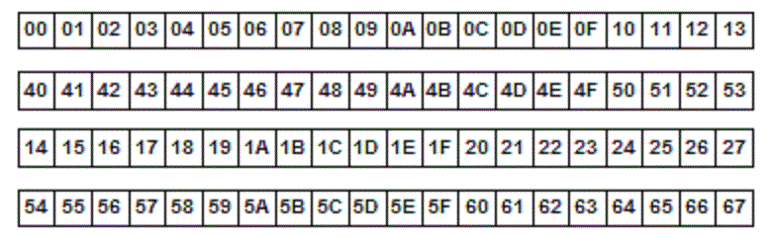](https://controllerstech.com/wp-content/uploads/2019/05/address-map-lcd20x4.png)

While setting an address we need to **OR (|)** it with the **0x80**. For eg if I want to set the cursor to **2nd row**, I have to set the address as **(0x80|0x40)**.

If you want to use a **16×4**LCD than the addresses for the **DDRAM**are shown below. Use the same code with just the change in address.

[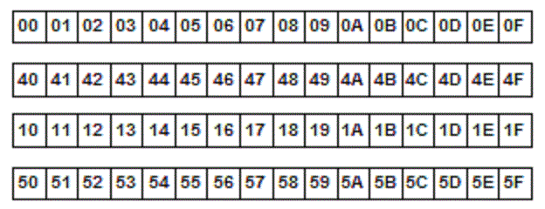](https://controllerstech.com/wp-content/uploads/2019/05/address-map-16x4.gif)